**Hayley Paul**

**Mission 1:**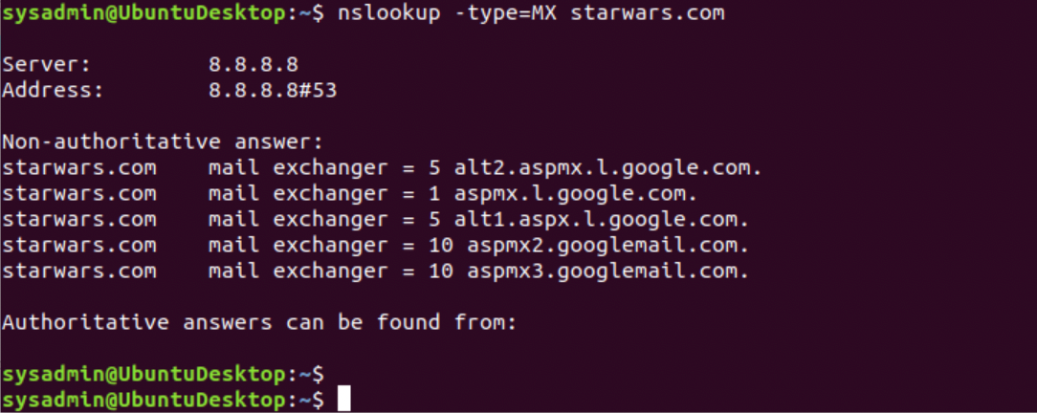

The Resistance isn’t receiving emails because the mail server's name is incorrect.

Servers should read:

starwars.com mail exchanger = 5 asltx.l.google.com.

starwars.com mail exchanger = 5 asltx.2.google.com.

**Mission 2:** 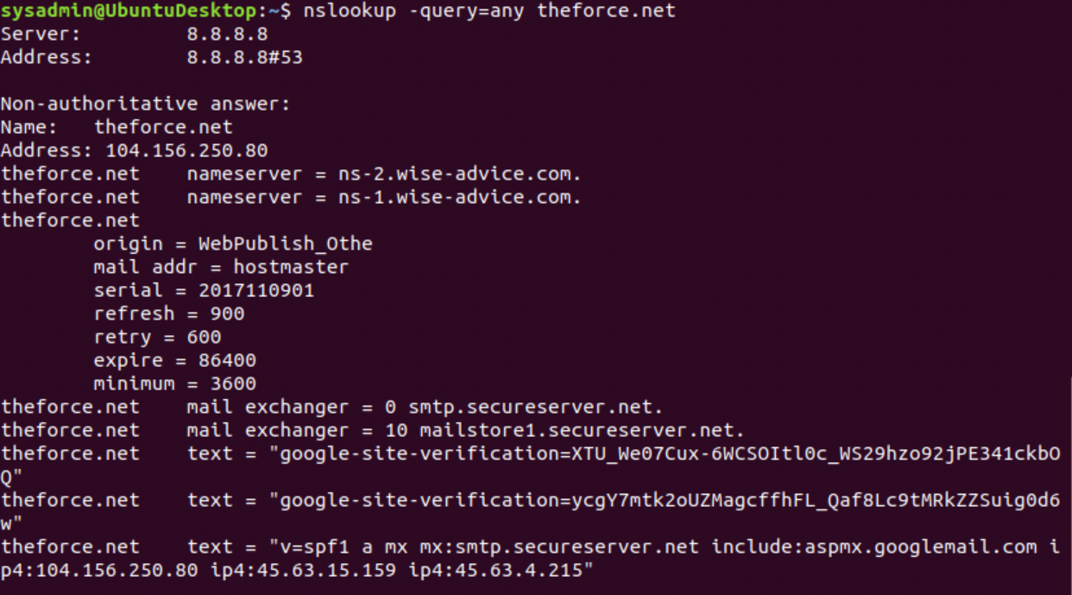

SPF for theforce.net : text = "v=spf1 a mx mx:smtp.secureserver.net include:aspmx.googlemail.com ip4:104.156.250.80 ip4:45.63.15.159 ip4:45.63.4.215"

The Force’s IP address 45.23.176.21 wasn’t added to the SPF Record. Record should read:

theforce.net text = "v=spf1 a mx mx:smtp.secureserver.net include:aspmx.googlemail.com ip4:104.156.250.80 ip4:45.63.15.159 ip4:45.63.4.215 ip4:45.23.176.21”

**Mission 3:**

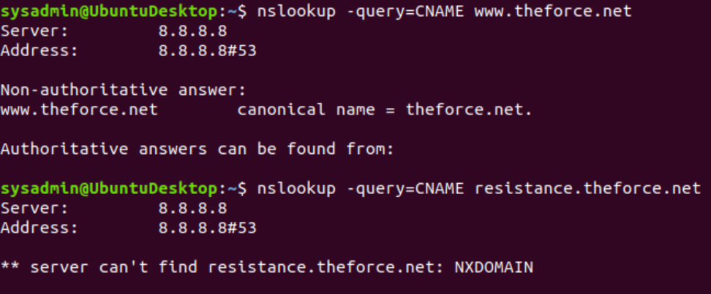

Subpage isn’t redirecting because it doesn’t exist.

Corrected DNS should read:

www.theforce.net canonical name = resistance.theforce.net.

**Mission 4:**

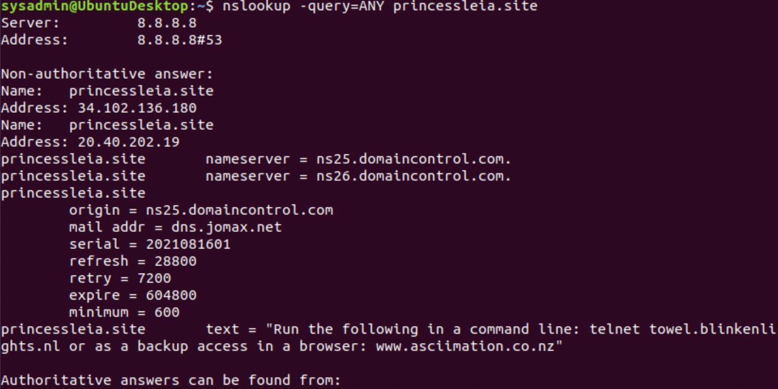

A new NS record that should be added:

princessleia.site nameserver = ns2.galaxybackup.com.

**Mission 5:** Shortest Path from Batuu to Jedha is: D + O + S.

**Mission 6**

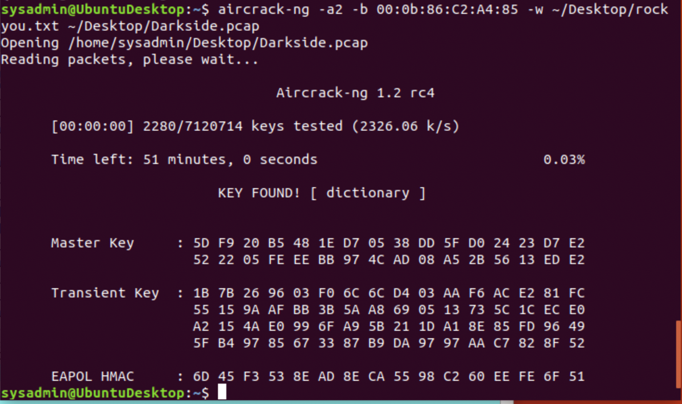

After decrypting and finding the key: dictionary.

I went to Wireshark. Edit - Preferences - Protocols - IEEE 802.11 - then enable Decryption - Decryption Keys - Edit - select WPA - add “dictionary”. Then okay.

When looking at the decrypted traffic, I found the following Host IP Addresses and MAC Addresses when filtering “ARP” traffic.

Dark Side Information

Host IP Addresses and MAC Addresses

172.16.0.101 (00:13:ce:55:98:ef)

172.16.0.1 (00:0f:66:e3:e4:01)

IP Addresses the resistance will use:

172.16.0.101 (00:13:ce:55:98:ef)

172.16.0.1 (00:0f:66:e3:e4:01)

**Mission 7**

